**Q14 - Create an android application to depict fragments.**

**Code -**

**MainActvitiy.java**

package com.example.fragmentsapp;  
import android.os.Bundle;  
import androidx.appcompat.app.AppCompatActivity;  
import androidx.fragment.app.Fragment;  
import androidx.fragment.app.FragmentManager;  
import androidx.fragment.app.FragmentTransaction;  
import android.view.View;  
import android.widget.Button;  
public class MainActivity extends AppCompatActivity {  
 @Override  
 protected void onCreate(Bundle savedInstanceState) {  
 super.onCreate(savedInstanceState);  
 setContentView(R.layout.*activity_main*);  
 Button buttonFragmentOne = findViewById(R.id.*buttonFragmentOne*);  
 Button buttonFragmentTwo = findViewById(R.id.*buttonFragmentTwo*);  
 buttonFragmentOne.setOnClickListener(new View.OnClickListener() {  
 @Override  
 public void onClick(View v) {  
 replaceFragment(new FragmentOne());  
 }  
 });  
 buttonFragmentTwo.setOnClickListener(new View.OnClickListener() {  
 @Override  
 public void onClick(View v) {  
 replaceFragment(new FragmentTwo());  
 }  
 });  
 }  
 private void replaceFragment(Fragment fragment) {  
 FragmentManager fragmentManager = getSupportFragmentManager();  
 FragmentTransaction fragmentTransaction = fragmentManager.beginTransaction();  
 fragmentTransaction.replace(R.id.*fragmentContainer*, fragment);  
 fragmentTransaction.commit();  
 }  
}

FragmentOne.java –

package com.example.fragmentsapp;  
import android.os.Bundle;  
import androidx.annotation.Nullable;  
import androidx.fragment.app.Fragment;  
import android.view.LayoutInflater;  
import android.view.View;  
import android.view.ViewGroup;  
public class FragmentOne extends Fragment {  
 @Nullable  
 @Override  
 public View onCreateView(LayoutInflater inflater, ViewGroup container, Bundle savedInstanceState) {  
 return inflater.inflate(R.layout.*fragment_one*, container, false);  
 }  
}

FragmentTwo - package com.example.fragmentsapp;  
import android.os.Bundle;  
import androidx.annotation.Nullable;  
import androidx.fragment.app.Fragment;  
import android.view.LayoutInflater;  
import android.view.View;  
import android.view.ViewGroup;  
public class FragmentTwo extends Fragment {  
 @Nullable  
 @Override  
 public View onCreateView(LayoutInflater inflater, ViewGroup container, Bundle savedInstanceState) {  
 return inflater.inflate(R.layout.*fragment_two*, container, false);  
 }  
}

XML Code -

<LinearLayout xmlns:android="http://schemas.android.com/apk/res/android"  
 android:layout_width="match_parent"  
 android:layout_height="match_parent"  
 android:orientation="vertical"  
 android:padding="16dp">  
  
 <Button  
 android:id="@+id/buttonFragmentOne"  
 android:layout_width="match_parent"  
 android:layout_height="wrap_content"  
 android:text="Load Fragment One" />  
 <Button  
 android:id="@+id/buttonFragmentTwo"  
 android:layout_width="match_parent"  
 android:layout_height="wrap_content"  
 android:text="Load Fragment Two" />  
 <FrameLayout  
 android:id="@+id/fragmentContainer"  
 android:layout_width="match_parent"  
 android:layout_height="0dp"  
 android:layout_weight="1" />  
</LinearLayout>

Fragment_one.xml

<LinearLayout xmlns:android="http://schemas.android.com/apk/res/android"  
 android:layout_width="match_parent"  
 android:layout_height=" wrap_content "  
 android:gravity="center"  
 android:orientation="horizontal">  
 <TextView  
 android:layout_width="wrap_content"  
 android:layout_height="wrap_content"  
 android:text="This is Fragment One"  
 android:textSize="20sp" />  
</LinearLayout>

Fragment_two.xml

<LinearLayout xmlns:android="http://schemas.android.com/apk/res/android"  
 android:layout_width="match_parent"  
 android:layout_height="match_parent"  
 android:gravity="center"  
 android:orientation="horizontal">  
 <TextView  
 android:layout_width="wrap_content"  
 android:layout_height="wrap_content"  
 android:text="This is Fragment Two"  
 android:textSize="20sp" />  
</LinearLayout>

Output :

**Q15 - Create a android application to show use of array adapter ?**

**Code –**

package com.example.arrayadapterdemo;

import android.os.Bundle;

import android.widget.ArrayAdapter;

import android.widget.ListView;

import androidx.appcompat.app.AppCompatActivity;

public class MainActivity extends AppCompatActivity {

@Override

protected void onCreate(Bundle savedInstanceState) {

super.onCreate(savedInstanceState);

setContentView(R.layout.activity_main);

// Sample data for the ListView

String[] fruits = {"Apple", "Banana", "Cherry", "Date", "Grape", "Kiwi", "Mango", "Orange", "Pineapple", "Watermelon"};

ListView listView = findViewById(R.id.listView);

ArrayAdapter<String> adapter = new ArrayAdapter<>(

this,

android.R.layout.simple_list_item_1,

fruits

);

// Setting the adapter to the ListView

listView.setAdapter(adapter);

}

}

XML CODE :

<LinearLayout xmlns:android="http://schemas.android.com/apk/res/android"  
 android:layout_width=" wrap_content  
 android:layout_height=" wrap_content  
 android:orientation="vertical"  
 android:padding="16dp">  
  
 <ListView  
 android:id="@+id/listView"  
 android:layout_width=" wrap_content "  
 android:layout_height=" wrap_content "  
 android:divider="@android:color/darker_gray"  
 android:dividerHeight="1dp" />  
</LinearLayout>

Output –

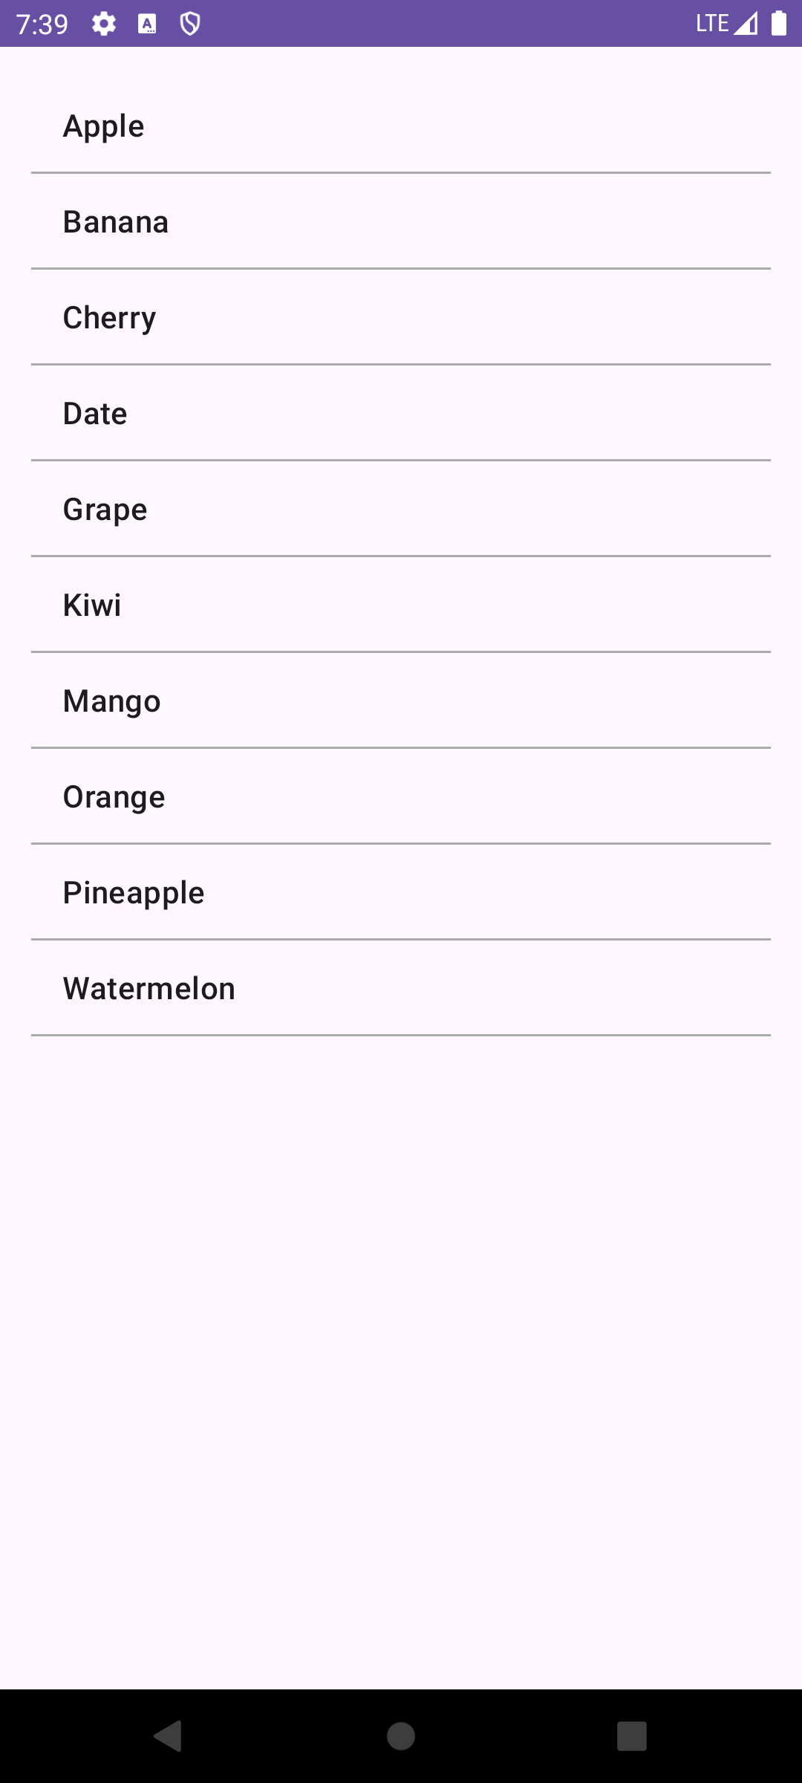

**16. Create an android application to step by step create a database..**

**CODE –**

package com.example.databaseapp;

import android.content.ContentValues;

import android.content.Context;

import android.database.Cursor;

import android.database.sqlite.SQLiteDatabase;

import android.database.sqlite.SQLiteOpenHelper;

public class DatabaseHelper extends SQLiteOpenHelper {

private static final String DATABASE_NAME = "Students.db";

private static final String TABLE_NAME = "students";

private static final String COL_1 = "ID";

private static final String COL_2 = "NAME";

private static final String COL_3 = "AGE";

public DatabaseHelper(Context context) {

super(context, DATABASE_NAME, null, 1);

}

@Override

public void onCreate(SQLiteDatabase db) {

db.execSQL("CREATE TABLE " TABLE_NAME " (ID INTEGER PRIMARY KEY AUTOINCREMENT, NAME TEXT, AGE INTEGER)");

}

@Override

public void onUpgrade(SQLiteDatabase db, int oldVersion, int newVersion) {

db.execSQL("DROP TABLE IF EXISTS " + TABLE_NAME);

onCreate(db);

}

public boolean insertData(String name, int age) {

SQLiteDatabase db = this.getWritableDatabase();

ContentValues contentValues = new ContentValues();

contentValues.put(COL_2 name);

contentValues.put(COL_3age);

long result = db.insert(TABLE_NAME, null, contentValues);

return result != -1; // Return true if insert is successful

}

public Cursor getAllData() {

SQLiteDatabase db = this.getWritableDatabase();

return db.rawQuery("SELECT * FROM " TABLE_NAME, null);

}

public boolean updateData(String id, String name, int age) {

SQLiteDatabase db = this.getWritableDatabase();

ContentValues contentValues = new ContentValues();

contentValues.put(COL_2, name);

contentValues.put(COL_3, age);

int results = db.update(TABLE_NAME, contentValues, "ID = ?", new String[]{id});

return result > 0;

}

public Integer deleteData(String id) {

SQLiteDatabase db = this.getWritableDatabase();

return db.delete(TABLE_NAME, "ID = ?", new String[]{id});

}

}

Javacode 2 :

package com.example.databaseapp;

import android.database.Cursor;

import android.os.Bundle;

import android.view.View;

import android.widget.Button;

import android.widget.EditText;

import android.widget.ListView;

import android.widget.Toast;

import androidx.appcompat.app.AppCompatActivity;

import java.util.ArrayList;

public class MainActivity extends AppCompatActivity {

DatabaseHelper databaseHelper;

EditText editName, editAge, editId;

Button btnAdd, btnView, btnUpdate, btnDelete;

ListView listView;

@Override

protected void onCreate(Bundle savedInstanceState) {

super.onCreate(savedInstanceState);

setContentView(R.layout.activity_main);

databaseHelper = new DatabaseHelper(this);

editName = findViewById(R.id.editName);

editAge = findViewById(R.id.editAge);

editId = findViewById(R.id.editId);

btnAdd = findViewById(R.id.btnAdd);

btnView = findViewById(R.id.btnView);

btnUpdate = findViewById(R.id.btnUpdate);

btnDelete = findViewById(R.id.btnDelete);

listView = findViewById(R.id.listView);

btnAdd.setOnClickListener(v -> {

String name = editName.getText().toString();

int age = Integer.parseInt(editAge.getText().toString());

boolean isInserted = databaseHelper.insertData(name, age);

showToast(isInserted ? "Data Inserted" : "Insertion Failed");

});

btnView.setOnClickListener(v -> viewAllData());

btnUpdate.setOnClickListener(v -> {

String id = editId.getText();

String name = editName.getText().toString();

int age = Integer.parseInt(editAge.getText().toString());

boolean isUpdated = databaseHelper.updateData(id, name, age);

showToast(isUpdated ? "Data Updated" : "Update Failed");

});

btnDelete.setOnClickListener(v -> {

String id = editId.getText().toString();

Integer deletedRows = databaseHelper.deleteData(id);

showToast(deletedRows > 0 ? "Data Deleted" : "Deletion Failed");

});

}

private void viewAllData() {

Cursor cursor = databaseHelper.getAllData();

if (cursor.getCount() == 0) {

showToast("No Data Found");

return;

}

ArrayList<String> data = new ArrayList<>();

while (cursor.moveToNext()) {

data.add("ID: " + cursor.getString(0) + ", Name: " + cursor.getString(1) + ", Age: " + cursor.getString(2));

}

ArrayAdapter<String> adapter = new ArrayAdapter<>(this, android.R.layout.simple_list_item_1, data);

listView.setAdapter(adapter);

private void showToast(String message) {

Toast.makeText(this, message, Toast.LENGTH_SHORT).show();

}

}

Xml code :

<LinearLayout xmlns:android="http://schemas.android.com/apk/res/android"

android:layout_width="match_parent"

android:layout_height="match_parent"

android:orientation="vertical"

android:padding="16dp">

<EditText

android:id="@+id/editName"

android:layout_width="match_parent"

android:layout_height="wrap_content"

android:hint="Enter Name" />

<EditText

android:id="@+id/editAge"

android:layout_width="match_parent"

android:layout_height="wrap_content"

android:hint="Enter Age"

android:inputType="number" />

<EditText

android:id="@+id/editId"

android:layout_width="match_parent"

android:layout_height="wrap_content"

android:hint="Enter ID (for update/delete)" />

<Button

android:id="@+id/btAdd"

android:layout_width="match_parent"

android:layout_height="wrap_content"

android:text="Add Data" />

<Button

android:id="@+id/btViews"

android:layout_width="match_parent"

android:layout_height="wrap_content"

android:text="View All Data" />

<Button

android:id="@+id/btUpdate"

android:layout_width="match_parent"

android:layout_height="wrap_content"

android:text="Update Data" />

<Button

android:id="@+id/btDelete"

android:layout_width="match_parent"

android:layout_height="wrap_content"

android:text="Delete Data" />

<ListView

android:id="@+id/listView"

android:layout_width=" wrap_content "

android:layout_height="wrap_content" />

</LinearLayout>

Output –

**17. Create an android application to perform CRUD operation in database.**

**CODE :**

Javafile 1 –

package com.example.crudapp;

import android.content.ContentValues;

import android.content.Context;

import android.database.Cursor;

import android.database.sqlite.SQLiteDatabase;

import android.database.sqlite.SQLiteOpenHelper;

public class DatabaseHelper extends SQLiteOpenHelper {

private static final String DATABASE_NAME = "StudentDB.db";

private static final String TABLE_NAME = "students";

private static final String COL_1 = "ID";

private static final String COL_2 = "NAME";

private static final String COL_3 = "AGE";

public DatabaseHelper(Context context) {

super(context, DATABASE_NAME, null, 1);

}

@Override

public void onCreate(SQLiteDatabase db) {

db.execSQL("CREATE TABLE " + TABLE_NAME + " (ID INTEGER PRIMARY KEY AUTOINCREMENT, NAME TEXT, AGE INTEGER)");

}

@Override

public void onUpgrade(SQLiteDatabase db, int oldVersion, int newVersion) {

db.execSQL("DROP TABLE IF EXISTS " + TABLE_NAME);

onCreate(db);

}

// CREATE

public boolean insertData(String name, int age) {

SQLiteDatabase db = this.getWritableDatabase();

ContentValues contentValues = new ContentValues();

contentValues.put(COL_2, name);

contentValues.put(COL_3, age);

long result = db.insert(TABLE_NAME, null, contentValues);

return result != -1;

}

// READ

public Cursor getAllData() {

SQLiteDatabase db = this.getWritableDatabase();

return db.rawQuery("SELECT * FROM " + TABLE_NAME, null);

}

public boolean updateData(String id, String name, int age) {

SQLiteDatabase db = this.getWritableDatabase();

ContentValues contentValues = new ContentValues();

contentValues.put(COL_2, name);

contentValues.put(COL_3, age);

int result = db.update(TABLE_NAME, contentValues, "ID = ?", new String[]{id});

return result > 0;

}

public Integer deleteData(String id) {

SQLiteDatabase db = this.getWritableDatabase();

return db.delete(TABLE_NAME, "ID = ?", new String[]{id});

}

}

JavaFile 2 –

package com.example.crudapp;

import android.database.Cursor;

import android.os.Bundle;

import android.view.View;

import android.widget.ArrayAdapter;

import android.widget.Button;

import android.widget.EditText;

import android.widget.ListView;

import android.widget.Toast;

import androidx.appcompat.app.AppCompatActivity;

import java.util.ArrayList;

public class MainActivity extends AppCompatActivity {

DatabaseHelper databaseHelper;

EditText editName, editAge, editId;

Button btnAdd, btnView, btnUpdate, btnDelete;

ListView listView;

@Override

protected void onCreate(Bundle savedInstanceState) {

super.onCreate(savedInstanceState);

setContentView(R.layout.activity_main);

databaseHelper = new DatabaseHelper(this);

editName = findViewById(R.id.editName);

editAge = findViewById(R.id.editAge);

editId = findViewById(R.id.editId);

btnDelete = findViewById(R.id.btnDelete);

listView = findViewById(R.id.listView);

btnAdd.setOnClickListener(v -> {

String name = editName.getText().toString();

int age = Integer.parseInt(editAge.getText().toString());

boolean isInserted = databaseHelper.insertData(name, age);

showToast(isInserted ? "Data Inserted" : "Insertion Failed");

});

btnView.setOnClickListener(v -> viewAllData());

btnUpdate.setOnClickListener(v -> {

String id = editId.getText().toString();

String name = editName.getText().toString();

int age = Integer.parseInt(editAge.getText().toString());

boolean isUpdated = databaseHelper.updateData(id, name, age);

showToast(isUpdated ? "Data Updated" : "Update Failed");

});

btnDelete.setOnClickListener(v -> {

String id = editId.getText().toString();

Integer deletedRows = databaseHelper.deleteData(id);

showToast(deletedRows > 0 ? "Data Deleted" : "Deletion Failed");

});

}

private void viewAllData() {

Cursor cursor = databaseHelper.getAllData();

if (cursor.getCount() == 0) {

showToast("No Data Found");

return;

}

ArrayList<String> data = new ArrayList<>();

while (cursor.moveToNext()) {

data.add("ID: " + cursor.getString(0) + ", Name: " + cursor.getString(1) + ", Age: " + cursor.getString(2));

}

ArrayAdapter<String> adapter = new ArrayAdapter<>(this, android.R.layout.simple_list_item_1, data);

listView.setAdapter(adapter);

}

private void showToast(String message) {

Toast.makeText(this, message, Toast.LENGTH_SHORT).show();

}

}

XML CODE :

<LinearLayout xmlns:android="http://schemas.android.com/apk/res/android"  
 android:layout_width="match_parent"  
 android:layout_height="match_parent"  
 android:orientation="vertical"  
 android:padding="16dp">  
 <EditText  
 android:id="@+id/editName"  
 android:layout_width="match_parent"  
 android:layout_height="wrap_content"  
 android:hint="Enter Name" />  
 <EditText  
 android:id="@+id/editAge"  
 android:layout_width="match_parent"  
 android:layout_height=" wrap_content "  
 android:hint="Enter Age"  
 android:inputType="number" />  
 <EditText  
 android:id="@+id/editd"  
 android:layout_width="match_parent"  
 android:layout_height="wrap_content"  
 android:hint="Enter ID (for update/delete)" />  
 <Button  
 android:id="@+id/btnAddd"  
 android:layout_width="match_parent"  
 android:layout_height="wrap_content"  
 android:text="Add Data" />  
 <Button  
 android:id="@+id/btnView"  
 android:layout_width="match_parent"  
 android:layout_height="wrap_content"  
 android:text="View All Data" />  
 <Button  
 android:id="@+id/btnUpdate"  
 android:layout_width=" wrap_content  
 android:layout_height="wrap_content"  
 android:text="Update Data" />  
 <Button  
 android:id="@+id/btnDelete"  
 android:layout_width=" wrap_content "  
 android:layout_height="wrap_content"  
 android:text="Delete Data" />  
 <ListView  
 android:id="@+id/listView"  
 android:layout_width="match_parent"  
 android:layout_height="wrap_content" />  
</LinearLayout>

OUTPUT :

**18. Create an android application to load Google map .**

**CODE :**

Manifest xml code :

<manifest xmlns:android="http://schemas.android.com/apk/res/android"

package="com.example.googlemapapp">

<uses-permission android:name="android.permission.ACCESS_FINE_LOCATION" />

<uses-permission android:name="android.permission.ACCESS_COARSE_LOCATION" />

<application

android:allowBackup="true"

android:label="GoogleMapApp"

android:theme="@style/Theme.AppCompat.Light.DarkActionBar">

<meta-data

android:name="com.google.android.geo.API_KEY"

android:value="lajdflkjasdflasjdflkasldfwlwl23lsd" />

<activity

android:name=".MapsActivity"

android:exported="true">

<intent-filter>

<action android:name="android.intent.action.MAIN" />

<category android:name="android.intent.category.LAUNCHER" />

</intent-filter>

</activity>

</application>

</manifest>

Javacode :

package com.example.googlemapapp;

import androidx.fragment.app.FragmentActivity;

import android.os.Bundle;

import com.google.android.gms.maps.CameraUpdateFactory;

import com.google.android.gms.maps.GoogleMap;

import com.google.android.gms.maps.OnMapReadyCallback;

import com.google.android.gms.maps.SupportMapFragment;

import com.google.android.gms.maps.model.LatLng;

import com.google.android.gms.maps.model.MarkerOptions;

import com.example.googlemapapp.databinding.ActivityMapsBinding;

public class MapsActivity extends FragmentActivity implements OnMapReadyCallback {

private GoogleMap mMap;

private ActivityMapsBinding binding;

@Override

protected void onCreate(Bundle savedInstanceState) {

super.onCreate(savedInstanceState);

binding = ActivityMapsBinding.inflate(getLayoutInflater());

setContentView(binding.getRoot());

// Obtain the SupportMapFragment and get notified when the map is ready to be used.

SupportMapFragment mapFragment = (SupportMapFragment) getSupportFragmentManager()

.findFragmentById(R.id.map);

mapFragment.getMapAsync(this);

}

@Override

public void onMapReady(GoogleMap googleMap) {

mMap = googleMap;

// Add a marker at a specific location and move the camera

LatLng sydney = new LatLng(-34, 151); // Example: Sydney, Australia

mMap.addMarker(new MarkerOptions().position(sydney).title("Marker in Sydney"));

mMap.moveCamera(CameraUpdateFactory.newLatLngZoom(sydney, 10));

}

}

Xml code :

<RelativeLayout xmlns:android="http://schemas.android.com/apk/res/android"

android:layout_width="match_parent"

android:layout_height="match_parent">

<fragment

android:id="@+id/map"

android:layout_width="match_parent"

android:layout_height="match_parent"

android:name="com.google.android.gms.maps.SupportMapFragment" />

</RelativeLayout>

OUTPUT :

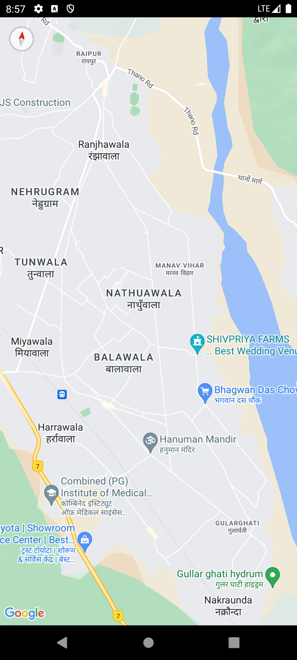

**19. Create an android application to show EMEI number and access the phone state .**

**Code :**

Manifest xml code :

<manifest xmlns:android="http://schemas.android.com/apk/res/android"

package="com.example.imeinumber">

<uses-permission android:name="android.permission.READ_PHONE_STATE" />

<application

android:allowBackup="true"

android:label="IMEI App"

android:theme="@style/Theme.AppCompat.Light.DarkActionBar">

<activity android:name=".MainActivity">

<intent-filter>

<action android:name="android.intent.action.MAIN" />

<category android:name="android.intent.category.LAUNCHER" />

</intent-filter>

</activity>

</application>

</manifest>

Java code :

package com.example.imeinumber;

import android.Manifest;

import android.content.pm.PackageManager;

import android.os.Build;

import android.os.Bundle;

import android.telephony.TelephonyManager;

import android.widget.TextView;

import android.widget.Toast;

import androidx.annotation.NonNull;

import androidx.appcompat.app.AppCompatActivity;

import androidx.core.app.ActivityCompat;

public class MainActivity extends AppCompatActivity {

private static final int PERMISSION_REQUEST_CODE = 100;

private TextView imeiTextView;

@Override

protected void onCreate(Bundle savedInstanceState) {

super.onCreate(savedInstanceState);

setContentView(R.layout.activity_main);

imeiTextView = findViewById(R.id.imeiTextView);

if (ActivityCompat.checkSelfPermission(this, Manifest.permission.READ_PHONE_STATE)

!= PackageManager.PERMISSION_GRANTED) {

ActivityCompat.requestPermissions(this,

new String[]{Manifest.permission.READ_PHONE_STATE}, PERMISSION_REQUEST_CODE);

} else {

displayIMEI();

}

}

private void displayIMEI() {

try {

TelephonyManager telephonyManager = (TelephonyManager) getSystemService(TELEPHONY_SERVICE);

if (telephonyManager != null) {

if (Build.VERSION.SDK_INT >= Build.VERSION_CODES.O) {

String imei = telephonyManager.getImei();

imeiTextView.setText("IMEI Number: " + imei);

} else {

String imei = telephonyManager.getDeviceId();

imeiTextView.setText("IMEI Number: " + imei);

}

}

} catch (SecurityException e) {

Toast.makeText(this, "Permission Denied!", Toast.LENGTH_SHORT).show();

}

}

@Override

public void onRequestPermissionsResult(int requestCode, @NonNull String[] permissions,

@NonNull int[] grantResults) {

super.onRequestPermissionsResult(requestCode, permissions, grantResults);

if (requestCode == PERMISSION_REQUEST_CODE) {

if (grantResults.length > 0) {

displayIMEI();

} else {

Toast.makeText(this, "Permission Denied!", Toast.LENGTH_SHORT).show();

}

}

}

}

Xml Code :

<RelativeLayout xmlns:android="http://schemas.android.com/apk/res/android"

android:layout_width="match_parent"

android:layout_height="match_parent"

android:padding="16dp">

<TextView

android:id="@+id/imeiTextView"

android:layout_width="wrap_content"

android:layout_height="wrap_content"

android:text="IMEI Number will appear here"

android:textSize="18sp"

android:layout_centerInParent="true" />

</RelativeLayout>

OUTPUT :

**Q21 - Create an application to implement login.**

**CODE** :

Javacode :

package com.example.loginapp;  
import android.os.Bundle;  
import android.view.View;  
import android.widget.Button;  
import android.widget.EditText;  
import android.widget.Toast;  
import androidx.appcompat.app.AppCompatActivity;  
public class MainActivity extends AppCompatActivity {  
 private EditText usernameEditText, passwordEditText;  
 private Button loginButton;  
 @Override  
 protected void onCreate(Bundle savedInstanceState) {  
 super.onCreate(savedInstanceState);  
 setContentView(R.layout.*activity_main*);  
 usernameEditText = findViewById(R.id.*username*);  
 passwordEditText = findViewById(R.id.*password*);  
 loginButton = findViewById(R.id.*loginButton*);  
 loginButton.setOnClickListener(new View.OnClickListener() {  
 @Override  
 public void onClick(View v) {  
 String username = usernameEditText.getText().toString();  
 String password = passwordEditText.getText().toString();  
 if (username.equals("user") && password.equals("password123")) {  
 Toast.*makeText*(MainActivity.this, "Login successful", Toast.*LENGTH_SHORT*).show();  
 } else {  
 Toast.*makeText*(MainActivity.this, "Invalid credentials", Toast.*LENGTH_SHORT*).show();  
 }  
 }  
 });  
 }  
}

xmlcode :

<?xml version="1.0" encoding="utf-8"?>

<LinearLayout xmlns:android="http://schemas.android.com/apk/res/android"

android:layout_width="match_parent"

android:layout_height="match_parent"

android:orientation="vertical"

android:padding="16dp">

<EditText

android:id="@+id/username"

android:layout_width="match_parent"

android:layout_height="wrap_content"

android:hint="Username"

android:inputType="text" />

<EditText

android:id="@+id/password"

android:layout_width="match_parent"

android:layout_height="wrap_content"

android:hint="Password"

android:inputType="textPassword" />

<Button

android:id="@+id/loginButton"

android:layout_width="match_parent"

android:layout_height="wrap_content"

android:text="Login" />

</LinearLayout>

OUTPUT :

